Random motor arm activity implicitly induces an internal and an external focus – The scientific evidence how two autonomous foci arise within grasp actions and how their roles evolutionarily have reversed

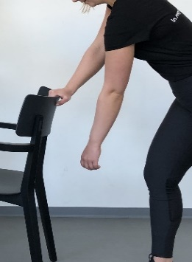 | 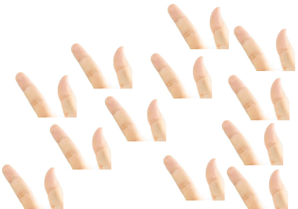 | 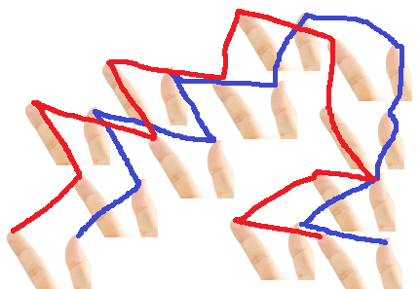

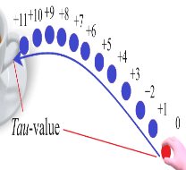 | 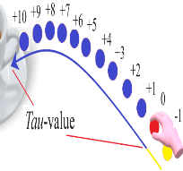 | 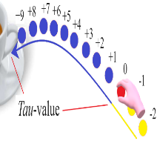 | 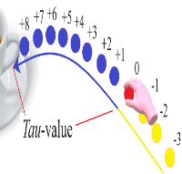 | 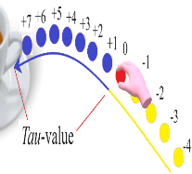 | 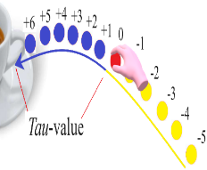
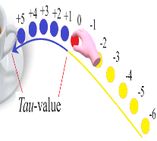 | 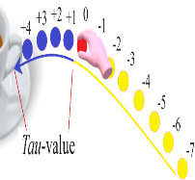 | 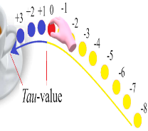 | 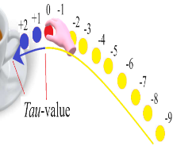 | 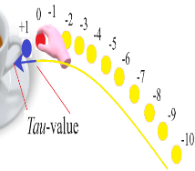 | 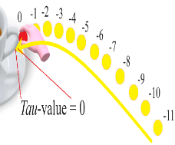

Caught In A Line
The explanatory model of all motoric movement actions

N.J. Mol
March 2024

Introduction

The explanatory model of the motoric movement action is capable of delineating all functional perception processes within any conceivable action. Nevertheless, challenges are encountered in its implementation within the scientific community due to the intrinsic nature of a new paradigm within a complex dynamic system. The explanatory model demands the simultaneous integration of multiple innovative mind steps.
In order to facilitate those necessary subsequent steps in science, a series of new articles is introduced, each time focusing on a different motoric action which will be assessed within the complete spectrum of (general) motor activity. The aim is to provide a broader perspective on specific motor activity required for goal-directed actions. Additionally, they universally demonstrate that motor activity always leads to the simultaneous autonomous perception of both internal and external movements, which can be appointed as primary or secondary, and finally, they elucidate all elements underlying the explanatory model of the motoric movement action.
This article centers around the motoric action of grasping. The explanation consists of three parts. The first part exclusively focuses on general motor activity and not on specific actions. Here, an action is defined as deliberate motor activity aimed at performing a specific task as a result of an egocentrically formulated intention. At the end of this part, grasping is fully explained in relation to general motor activity. In contrast to the first part, the second part addresses deliberate c.q. specific goal directed actions where an egocentrically intention is formulated to for example grasp a coffee cup. Two action strategies are highlighted in this part, logically stemming from the general motor activity mentioned in the first part. The concluding part emphasizes the relationship between the discussed motor activities and the explanatory model of the motoric movement action.

Part 1 - Internal motor (movement) activity when no deliberate goal-directed action is involved

The explanatory model of the motoric movement action identifies all functional perception processes within any conceivable goal-directed action. In which the fundamental assumption encompasses that the action arises from explicitly formulating a particular egocentric will. However, in this part, we do not assess a specific motor action with an egocentric intention yet. In here we solely focus on general motor activity. The distinction between mere motor activity and conscious goal-directed actions provides valuable insight into the broad spectrum of motor (movement) activity.

- Basic exercise (passive arm without a spoon)

The entire explanation is built upon a basic exercise, involving a forward-leaning body posture with one arm hanging passively downward. This posture is often used in physiotherapy exercises to allow isolated movement of the arm. That is strenuously not the intention of this exercise. It is essential to keep the arm entirely passive during the execution of the basic exercise.

 | 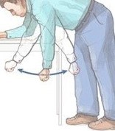 | 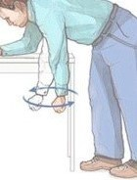

Images: The basic exercise illustrates a forward-leaning body position with a passive arm. Despite the apparent action in the images, the primary goal is to develop and observe other body actions and notice how they laterally influence the movement of the passive arm.

Although the hanging arm is prominently present, you are now asked not to focus on it specifically. Conversely, the emphasis must be put on developing other than arm activities (knee, torso, head, foot action, etc.) and observing whether the passive arm is going to move.

Conclusion of the basic exercise (passive arm without a spoon)

It can be conclusively observed that you are capable to (secondarily) perceive movement of all separate positions P of the outside of a passive arm by directing (primary) attention to an entirely different internal motor activity. This observation carries the following factual conclusions:
- While there is nothing predictable about where the passive arm will move, as random internal motor activity will always result in random or chance movements of the passive arm, there is, on the other hand, a very essential fact to note. All individual external points/positions P of the arm will always have to be connected c.q. will always have to emerge from each other. If we, for example, were to focus on three points of the arm, such as the fingertips, knuckles of the fist, and the elbow, you cannot escape the factual conclusion that all those points always move in a line segment shape and that it always involves only one (!) line segment shape. So, this applies to all places on the arm, and within there it can also factually be established that each position P of the arm will move like a marble in a marble run. The current position P (0) of each piece of the arm will always mark the separation between the manifest positions P (-x) and the future positions P (+x).
- The second very essential conclusion encompasses the fact that the two movements have a causal connection, but the perception of the movement of internal motor activity (knee, torso, head, foot action, etc.) has absolutely nothing to do with the perception of the movement within the linear form where all separate parts of the arm become a part of.

- Basic exercise (passive arm with a spoon)

A crucial aspect of the preceding conclusion involves the fact that internal sensorimotoric movements implicitly lead to a movement of, for example, the fingertips over an external line segment shape outside the body. There is, therefore, a direct causal relationship between these two movements, with the remarkable phenomenon that, without internal motor activity, an action trajectory shape of the fingertips is just not capable to occur. However, it is essential to establish that the perception of the movement of the fingertips over an action trajectory shape outside the body, in spite of this crucial causal relationship, has no connection with the perception of internal sensorimotoric movements. To further clarify this intriguing duality, the basic exercise is repeated, with the sole difference that the hand of the passive arm is holding a spoon. The entire exercise proceeds identically to the description above.

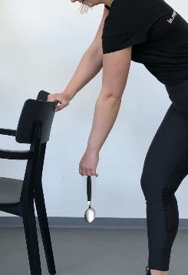 | 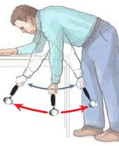 | 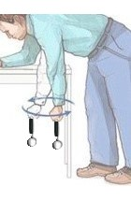

Images: In the repetition of the basic exercise, only a spoon is added, while the exercise remains unchanged. It is crucial, once again, not to develop conscious arm action but merely to observe how other bodily actions influence the entirely passive arm with the spoon. Now you can factually establish that all separate positions P of the arm but also all separate positions of the spoon will start to move in line segment shapes. Due to the fact that all those separate positions can only emerge from each other c.q. they will always be interconnected.

Conclusion of the basic exercise (passive arm with a spoon)

Like in the first version of the basic exercise it can be factually established that you are capable to (secondarily) perceive movement of all separate positions P of the outside of a passive arm, now holding a spoon, by directing (primary) attention to an entirely different internal motor activity. This observation carries the following factual conclusions:
- While there is nothing predictable about where the passive arm with the spoon will move, as random internal motor activity will always result in random or chance movements of the passive arm with the spoon, there is, on the other hand, a very essential fact to note. All separate points/positions P of the arm and all separate points/positions P of the spoon will always have to be connected c.q. will always have to emerge from each other. Once again, the three previously mentioned arm positions (the fingertips, the knuckles of the fist, and the elbow) will create a line segment shape, but also all the separate positions of the spoon also form separate lines. If you focus, for example, on the handle or the bowl of the spoon, you cannot escape the factual conclusion that all those points always move in a linear form, and that, too, always involves exact one (!) entire line segment shape. So, all separate positions of the arm and of the spoon are going to traverse a linear form and within there it can also factually be established that each position P of the arm and of the spoon will move like a marble in a marble run. The current position P (0) of each piece of the arm and spoon will always mark the separation between the manifest positions P (-x) and the future positions P (+x).
- The second highly essential conclusion, as mentioned in the first version of the basic exercise, remains fully intact here as well. The perception of the movement of internal motor activity (knee, torso, head, foot action, etc.) has absolutely nothing to do with the observation of the line segment shapes that all parts of the arm and now also all parts of the spoon become a part of. However, the new aspect introduced by the spoon concerns the fact that a spoon is an inanimate object. What leads to the astonishing factual conclusion that, for instance, we can observe the movement of the spoon's bowl over a line segment shape, but we can only generate motor activity up to the outer surface of the handle of the spoon.
The perplexing aspect of this realization may be the fact that the movement of the spoon's bowl over a line segment shape is entirely dependent on a completely different internal motoric movement. Without this source of action, the spoon's bowl will never move. Additionally, the confirming aspect of this realization may concern the conviction that the perception of the movement of the spoon's bowl over a line has absolutely no connection with the perception of internal motor movement activity.

- The basic exercise in relationship to motoric arm activity inducing movement of the fingertips
If we define an action as conscious motor activity in which a specific goal is pursued from an ego-centrically formulated will, then the explanation in the entire first part of this article falls outside the framework of actions. In this paragraph, we still do not assume a conscious goal-directed action, but rather build upon what the basic exercises demonstrate.

Images: The basic exercises entail the manipulation of a passive arm through distinct motor activities originating elsewhere in the body. However, the explanatory model of the motoric movement action illustrates that the internal source of movement initiation for, say, the fingertips, is inconsequential. Should one choose to concentrate solely on, for instance, the thumb and ring finger, their manipulation could be solely orchestrated by corresponding internal finger actions. Which also underscores the critical observation that not only the fingertips will become part of a linear trajectory, but all components of the finger as well.
As the preceding paragraph demonstrates, the basic exercise can be readily translated into an action aimed at moving the fingertips. To maximize the distinction between the perception of fingertip movement and the perception of internal motor activity, thereby elucidating the principles, participants were initially instructed to refrain from engaging in any arm activity.
However, the distance between the fingertips and the internal motor activity doesn’t matter at all because even if you direct your primary focus to internal motor arm activity, you will effectively observe that the outer surface of the fingertips moves randomly through the air. Whether you engage in upper or lower arm activity, or solely hand or even finger action, the same principles apply. Once again, you can only factually observe that the position P (0) of the fingertips, in the current action, must always derive from preceding positions, meaning that all positions P of the entire finger (and so also the tips of the fingers) are always confined to one single line segment shape.

Conclusion basic exercise in relationship to motoric arm activity inducing movement of the fingertips

So, also during motor actions where one primarily focuses on any (internal) motor arm activity, it is possible to secondarily perceive movement of the outer surface of the fingertips constructing line segment shapes. This observation alone is sufficient to draw the following factual conclusions:
- Although there is nothing predictable about where the fingertips will move, as random internal motor activity will always result in random or chance movements of the fingertips, there is, on the other hand, a very essential fact to note. All separate points/positions P of the fingertips will always have to be connected c.q. will always have to emerge from each other. Due to which one can conclude that all those points always construct a linear form, and that, too, always involves exact one (!) entire line segment shape. The fingertips will move in that linear form in the same universal manner as a marble moves within a marble run. In which the current position P(0) of the fingertips will always serve as the precise separation between all manifest positions P(-x) and all future positions P(+x).
- The second crucial conclusion follows the same logic as the other basic exercises. The perception of movement in relationship to internal motor arm activity has absolutely nothing to do with the perception of the movement of the fingertips within the line segment shape that all parts of the fingers become part of.
The perplexing aspect of this observation could be the realization that the movement of the fingertips along a line segment shape is entirely dependent on a completely different internal motor movement. Without this source of action, the fingertips would never be able to move. Additionally, the confirming aspect of this observation could be the conviction that the perception of the movement of the fingertips along a line is absolutely unrelated to the perception of internal motor (movement) activity.

Part 2 - Internal motor (movement) activity when a deliberate goal-directed action is involved

The explanatory model of the motoric movement action encompasses the clarification of all functional perception processes within any conceivable action, assuming that these are conscious actions driven by an egocentrically formulated will, with a clearly defined specific goal. So, the motor movements in the first part specifically did not involve goal-directed actions. Which aimed at placing motor activity in a larger context. Conversely within the second part, general motor activity will now be translated towards specific motoric actions. Although the explanatory model of the motoric movement action is emphasized more in this part, the explanation within this section still aims to clarify the entire spectrum of motor (movement) activity.
So, within the second part we do assume deliberate goal-directed actions where an egocentric will is formulated to achieve a specific goal and in this chapter the movement of the fingertips towards the handle of a coffee cup encompasses the main issue. The basic exercise clearly shows that two possible action strategies c.q. execution perspectives can be pursued in this regard.

- Execution perspective 1 - Primary focus on internal motor movements reaching to the outer surface of the fingertips and secondary focus on the movement of the fingertips along an external action trajectory shape

The basic exercises from the first part clearly demonstrate that with primary focus on internal motor activity, we can randomly move our fingertips (externally) through the air. However, this random movement poses a problem when one formulates the egocentric intention to precisely grasp a coffee cup by its handle. We can, with primary focus on internal motor activity, make our fingertips cover a tremendous amount of space in the air within a few minutes, but it is far from efficient and effective (parsimonious).



Images: Even when you consciously want to manoeuvre your fingertips towards a coffee cup, it remains a strategy to primarily focus on internal motor activity, while secondarily observing whether the fingertips will eventually reach the handle of the cup. Although this approach may require a considerable amount of luck and/or patience, it is a plausible action strategy. However, it is not an economical one, and it becomes evident quite quickly that organisms would not choose to develop ecologically in this manner.

- Execution perspective 2 - Primary focus on the movement of the fingertips along an external action trajectory shape and secondary focus on internal motor movements reaching to the outer surface of the fingertips

Contrary to the description of random motor activity within the basic exercises within the first chapter of this article and also in contrast to the previous action strategy, when it comes to the emergence of a deliberate goal-directed action, one can adopt a completely different execution perspective. It would indeed be by far the most parsimonious (ecological) solution to first construct a perceptual image of a latent action trajectory shape and then proceed to execute it.

Images: It is most parsimonious to first create a perceptual image of an (efficient and effective) latent action trajectory shape along which the fingertips can be successfully moved towards a coffee cup, and then proceed to actually execute it.
In the second execution perspective, attention roles are reversed. Here, the primary focus shifts to tracking the fingertips' progress within the action trajectory shape, while internal motor activity becomes the secondary focus. This is a complete reversal from the basic exercise in the first part, where one must passively observe that motor activity should now passively follow the primary focus. Although it would be the most economical action strategy, reversing roles demands significantly more cognitive capacity. Unlike the first execution perspective, where starting the action is straightforward, the second perspective requires mastering the following essential cognitive skills:
- It demands that first a perceptual image of a latent action trajectory shape is constructed over which the fingertips can be successfully moved towards the coffee cup.
- A highly intricate system must be present to mediate the (perception of) movement of the fingertips within the perceptual representation of the latent action trajectory shape. Even if we reverse the roles of focus, it remains true that the fingertips can only be propelled by (the perception of) an entirely different autonomous (internal) process. While we may aim to compel the fingertips to accurately align with the perceptual representation of the latent action trajectory, the autonomous nature of motor activity means that the fingertips will inevitably deviate from this representation at every point P.

Part 3 – General conclusion

The explanatory model of the motoric movement action is capable of appointing all functional perception processes within any conceivable action. However, its implementation in the scientific world encounters several challenges. It represents an entirely new paradigm and involves an explanation within a complex dynamic system where multiple new conceptual mind steps must be combined simultaneously. Therefor the goal is to try to enhance the insights around the explanatory model, and for that purpose, the preceding paragraphs zoomed in on the entire spectrum of motor activity. From a generally recognizable image, a translation was made to the core concepts and thought processes demanded by the explanatory model of the motoric movement action.
In the end, within this article, two possible action perspectives were identified based on general motor activity. Without any reasonable doubt it becomes clear that the second perspective, where the primary focus is pointed at the construction and execution of a perceptual image of a latent (external) action trajectory shape, will be far more superior to the first mentioned action strategy. However, this ultimate parsimonious solution also reveals which additional conditions the most superior action strategy should meet:
- Firstly, an organism must have the cognitive ability to create a perceptual image of a latent action trajectory, over which, in the present action, the fingertips will be successfully moved towards a coffee cup. Regarding this first condition, the explanatory model of the motoric movement action has provided universal scientific evidence that we create such a perceptual image within every conceivable action. This has been specifically addressed within computer, grasping and throwing tasks, but it can easily be adapted to any conceivable action.
- Secondly, an organism must have the cognitive ability to mediate the movement of the fingertips within that perceptual image of a latent action trajectory. The mere quintessence of this article encompasses namely that motor activity is a completely autonomous phenomenon and although it has a direct causal relationship with the movement of the fingertips within an action trajectory shape, the outside of the fingertips will never be able to move by themselves. So, we might be intensely motivated to reverse the roles of the primary and secondary focus and envision very neat and straight (optimally economical) action trajectory shapes but due to the autonomy of the perception of both movements, we simply cannot execute them in that way. The autonomous (mainly visual) perception of the movement of the fingertips will eagerly try to follow the perceptual image of the latent action trajectory shape, but the autonomous (internal) proprioceptive perception towards the outer surface of the fingertips will externally cause the fingertips to deviate at every position P within the perceptual image of the latent action trajectory shape.
The explanatory model of the motoric movement action thus concludes that there must be a very heavy significant system to mediate the ever-deviating movements of the fingertips within an ever-deviating action trajectory shape each consecutive time frame. Regarding this second condition the explanatory model finds that this very heavy system is present within the processing processes of the perception c.q. is present within the functioning of the cortical streams and, based upon current scientific literature, it asserts that there is a double and mutual relationship between the dorsal and ventral stream. In the present goal-directed motoric action, the dorsal stream is mainly related to the processing of perceptions concerning the specific position of the fingertips, and the ventral stream is mainly related to the processing of perceptions concerning the perceptual image of the whole action trajectory shape. However, this must be seen as mutual. At any time frame t or at any point P (0) of the action, one perceives the position of the fingertips relative to the action trajectory shape and vice versa. So, the dorsal stream mainly processes the position of the fingertips, but this is always related to the action trajectory shape, and conversely, the ventral stream mainly processes the progression within the action trajectory shape, but this is always related to the specific position of the fingertips.
This dual and reciprocal collaboration leads to random deviations of the fingertips from the perceptual image of the latent action trajectory shape at every position P(0). As a result, the ventral stream promptly needs to renew c.q. update the perceptual image of the remaining latent action trajectory shape, which immediately becomes the compelling new output situation in relation to the dorsal stream. This process repeats with each new deviation. This inevitable consequence causes the fingertips to move involuntarily in a zigzag or jerky manner within the perceptual image of the action trajectory shape due to the (very small) reaction time inherent in this dual and reciprocal collaboration.

Hence, you must also realize that when grasping a coffee cup, where we typically focus on the movement of the fingertips, all other mentioned body parts also move in linear forms. This demonstrates that the related perception processes are entirely subjective and depend on the chosen focus.
Indeed, you can factually ascertain that your own body, from birth to the end of life, is also confined within one extensive line segment shape. Your body at every position P(0) is, in fact, bound to the penultimate position P(-1) and the subsequent position P(+1). There is simply no escaping it. You are factually “Caught In A Line”.
https://www.researchgate.net/publication/336880958_The_explanatory_model_of_all_motoric_movement_actions_-_The_Marble_Run
The explanatory model of the motoric movement action demonstrates in numerous articles that the two perceptions of two types of movements are autonomous because they belong to the incompatible worlds of inside and outside the body. Therefore, there can never be a blending of the two.
Hence, you must realize that when eating soup, where we typically focus on the movement of the spoonbowl, all other mentioned body and spoon parts also move in line segment shapes. This demonstrates that the related perception processes are entirely subjective and depend on the chosen focus.
Two essential omissions should be noted in the animations: 1. Only a limited number of positions of fingertips are represented. If you engage in a few minutes of random motor activity, the entire environment should be filled with rings. 2. The connection of successive positions P of fingertips cannot be captured in an animation. The perception of the fingertip movement involves a continuous (smooth) line of fingertips. The red and blue line represents this continuous connection but does not actually show fingertips. Therefore, you need to create a hybrid perceptual representation, which you can only really perceive by actually grasping an object.
Each additional position P to be bridged will result in an exponential increase in deviation possibilities.
https://www.researchgate.net/publication/372719694_When_moving_a_pointer_on_a_computer_screen_you_are_mainly_attentive_to_where_'nothing'_is_-_The_scientific_evidence_regarding_visual_perception_within_each_motor_action
https://www.researchgate.net/publication/372290282_Grasping_encompasses_two_consecutive_autonomous_phases_-_The_scientific_proof_that_we_tactically_construct_an_action_trajectory_shape_prior_to_the_factual_execution_of_that_exact_same_action_trajector?_sg%5B0%5D=cjBGD1Dj5IxR2T4se38lo9o1z_M-KwSU49eb_oQsTOUjibSgy5M67E9dyDJ2vYL6jmizwVBbPYrgk9NU6pmmALDQpNZJERFlrXLCWSXY.BBjj_0oQKGMN_JQZfSCEjGE1eN9IjRkkPyAjEjWIaxLJGM1U2MeXLYMQPb3Fz_XmE18jNVnKKf8WfOSPcG4l1w&_tp=eyJjb250ZXh0Ijp7ImZpcnN0UGFnZSI6ImhvbWUiLCJwYWdlIjoicHJvZmlsZSIsInBvc2l0aW9uIjoicGFnZUNvbnRlbnQifX0
https://www.researchgate.net/publication/371912704_The_scientific_proof_that_we_primarily_start_with_the_construction_of_a_perceptual_image_of_an_outgoing_ball_trajectory_shape_prior_to_the_factual_execution_-_The_complete_explanation_of_the_free_thro
The zigzag collaboration is vividly illustrated in the execution of the nerve spiral, which legitimacy is solely based on this jerky phenomenon. While you may successfully traverse a spiral, you can quickly empirically determine that you will never be able to construct straight action trajectory shapes because the ring will always deviate randomly, and the reactions of the cortical streams demand essential reaction time. Additionally, you will soon conclude that you simply cannot create an identical action trajectory shape for any conceivable action.

